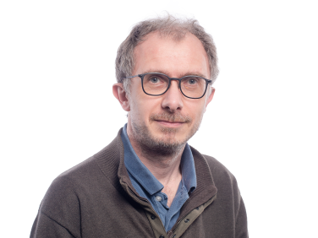

Benjamin Hanoune (PhD Molecular Physics 1994, Habilitation in Physical Chemistry and Atmospheric Sciences 2012) entered PC2A laboratory as a CNRS researcher in 1998, after two postdoctoral positions, first in Nobeyama Radio Observatory (Japan) then at the University of Kansas. His scientific interests shifted from the spectroscopy of molecules in the interstellar medium and planetary atmospheres to atmospheric chemistry (reactivity and pollutant monitoring) and indoor air chemistry, where he is currently developing the use of miniature pollutant sensors. He is also involved in science public outreach.

